**FACULTY PERFORMANCE INFORMATION**

**A Project Report**

***Submitted by***

## DHWANI SHAH

**NISHEE SHELAT**

## YASHESH SORATHIA

***Under the Guidance of***

## KAMAL MISTRY

***in partial fulfillment for the award of the degree of***

## B.TECH

**IN COMPUTER SCIENCE**

At



**MUKESH PATEL SCHOOL OF TECHNOLOGY, MANAGEMENT AND ENGINEERING**

**APRIL 2020**

**DECLARATION**

We, Dhwani, Nishee and Yashesh, Roll Nos. 25, 30 and 41, B Tech (Computer Engineering), IV semester understand that plagiarism is defined as anyone or combination of the following:

1. Un-credited verbatim copying of individual sentences, paragraphs or illustration (such as graphs, diagrams, etc.) from any source, published or unpublished, including the internet.
2. Un-credited improper paraphrasing of pages paragraphs (changing a few words phrases, or rearranging the original sentence order)
3. Credited verbatim copying of a major portion of a paper (or thesis chapter) without clear delineation of who wrote what. ( Source: IEEE, The institute, Dec. 2004)
4. I have made sure that all the ideas, expressions, graphs, diagrams, etc., that are not a result of my work, are properly credited. Long phrases or sentences that had to be used verbatim from published literature have been clearly identified using quotation marks.
5. I affirm that no portion of my work can be considered as plagiarism and I take full responsibility if such a complaint occurs. I understand fully well that the guide of the seminar/ project report may not be in a position to check for the possibility of such incidences of plagiarism in this body of work.

Signature of the Students: 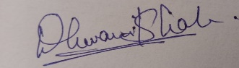 , 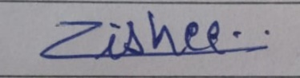 , 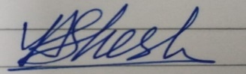

Names: Dhwani Shah, Nishee Shelat, Yashesh Sorathia

Roll Nos. : E025, E030, E041

Place: Mumbai

Date: 5th April 2020

## CERTIFICATE

This is to certify that the project entitled “FACULTY PERFORMANCE INFORMATION” is the bonafide work carried out by _Dhwani Shah, Nishee Shelat, Yashesh Sorathia_ of B Tech, MPSTME (NMIMS), Mumbai, during the IV semester of the academic year 2019-20, in partial fulfillment of the requirements for the Course Programming Language.

___________________

Prof. Kamal Mistry

Internal Mentor

_______________________ ________________________

Examiner 1 Examiner 2

**ACKNOWLEDGEMENT**

We would like to convey our heartfelt acknowledgments to our professors, Prof. Kamal Mistry and Prof. Pankti Doshi for helping us with their advice and recommendations throughout the course of project and also for understanding the need for extension considering the extreme circumstances. We would also like to thank our classmates for helping us out with issues that considered of small mistakes and giving us suggestions that they learnt during their project.

## Table of contents

**CHAPTER NO. TITLE PAGE NO.**

1. INTRODUCTION 5
2. SOFTWARES AND API USED 5

WITH DESCRIPTION

1. METHODS IMPLEMENTED 6
2. SCREENSHOTS 7
3. CONCLUSION & FUTURE SCOPE 11

**FACULTY PERFORMANCE INFORMATION**

**INTRODUCTION**

The faculty performance information portal would need a database to store the necessary data about a particular faculty and their accomplishments. The database used in this project consists of multiple tables of professional and personal parameters that help us understand and view the performance of a faculty in the way we desire to. The major professional table consists of books, articles, conferences, papers, patents, projects, etc. whereas the personal table include faculty’s name, age, experience of years, address, email and contact information.

A system like this requires an impressive User-Interface that catches the eye of the viewer and also be appropriate and user-oriented so as to be used on a daily basis

**SOFTWARES AND API USED**

For the front-end part, Python code was written in IDLE 3.7 32-bit. We have imported python libraries like Tkinter (for GUI), sqlite3 (for database), PIL (for displaying images), matplotlib (for pie charts). The following libraries were used to make the foundation of our project as well as to make it visually appealing.

For the back-end database, we have used DB Brower to store our details about Faculty

( personal/professional ) in tables. These tables are then accessed by the help of sqlite3 library in Python to run queries.

**METHODS IMPLEMENTED**

Faculty Performance Information System needs a lot of data to be stored, and as files are an in-efficient way to store all that data. Therefore, we have used a database to store all the details of the Faculty ( personal/professional ).There is also connectivity provided to retrieve data from the database. This connectivity is implemented with the use of functionality. These functionalities were used by importing the library SQLite 3. These functionalities are as below:

* **Search by year** : Here, the input would be any particular year (eg. 2015) and the output would be all the professional parameters (books, events, conferences, etc ) that occurred in that specific year.
* **Search by professional parameter**: Here, there would be radio buttons of different parameters and after selection of one of the radio buttons all the details about the said parameter accomplished by various faculties will be displayed.
* **Personal Information:** Here, a drop down menu will be provided with the names of all the faculties. After selection of a particular Faculty name, all personal details about the said faculty will be displayed.
* **Professional Information:** Here, a drop down menu will be provided with the names of all the faculties. After selection of a particular Faculty name, all the number of accomplishments they have done in a particular parameter are displayed.
* **Statistical Data: :**Here, a drop down menu will be provided with the names of all the faculties. After selection of a particular Faculty name ,all the professional information are displayed in a pie chart format after analyzing the data and converting it into a percentage format.

A Gallery is created where lots of pictures were inserted , regarding various conferences and papers, with the help of PIL library to make the GUI look presentable and attractive. This Gallery helps provide the validation of the information mentioned.

**SCREENSHOTS**

**Front Page:**

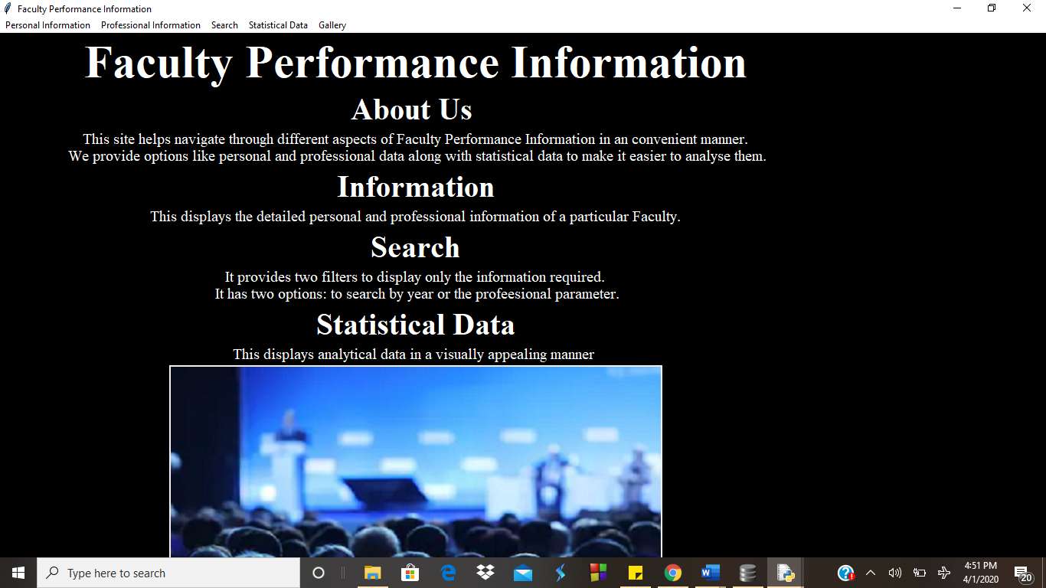

**Personal Information:** All the Personal Information of a certain Faculty.

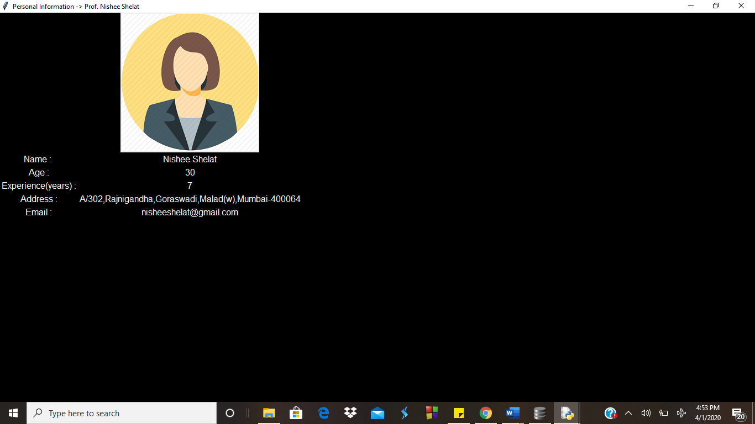

**Professional Information:** All the number of accomplishments they have done in a particular parameter are displayed.

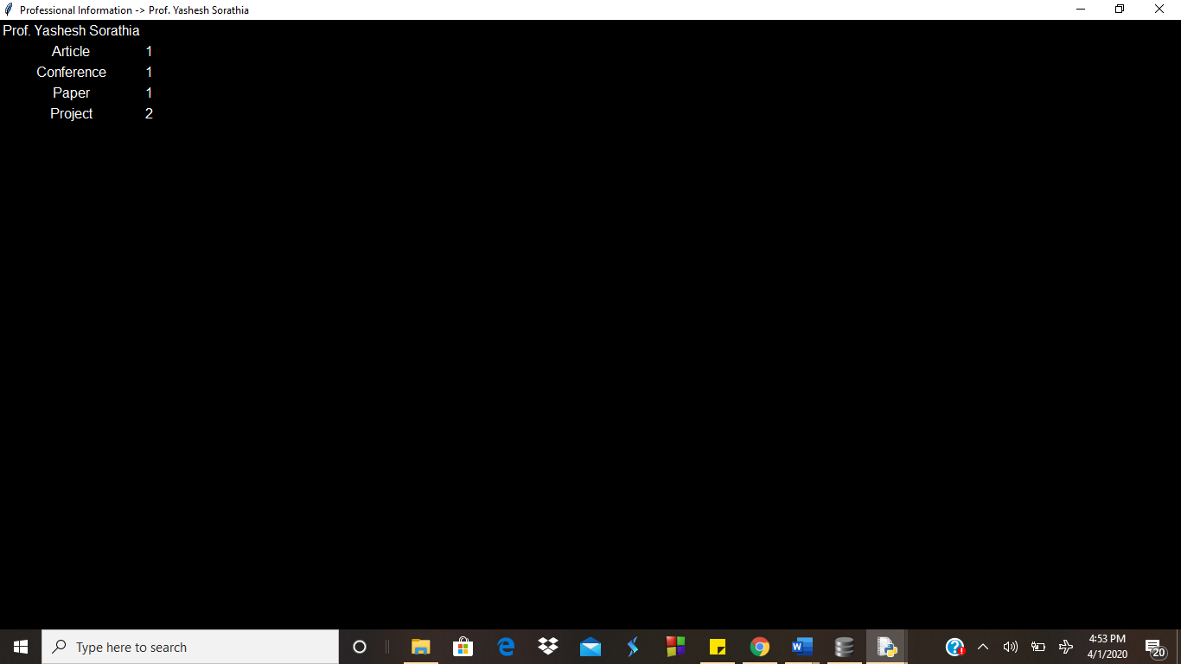

**Search by year:** The input would be any particular year (eg. 2015) and the output would be all the professional parameters (books, events, etc ) that occurred in that year.

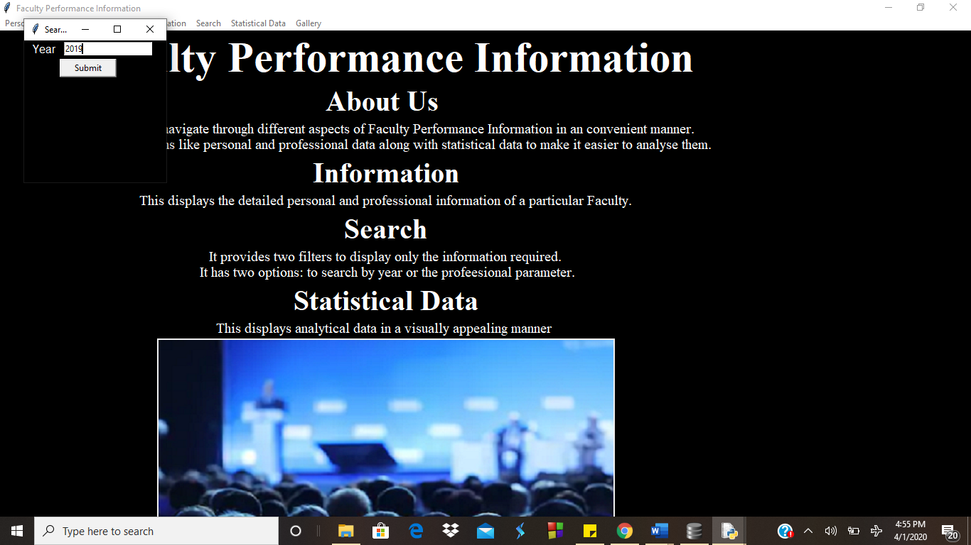 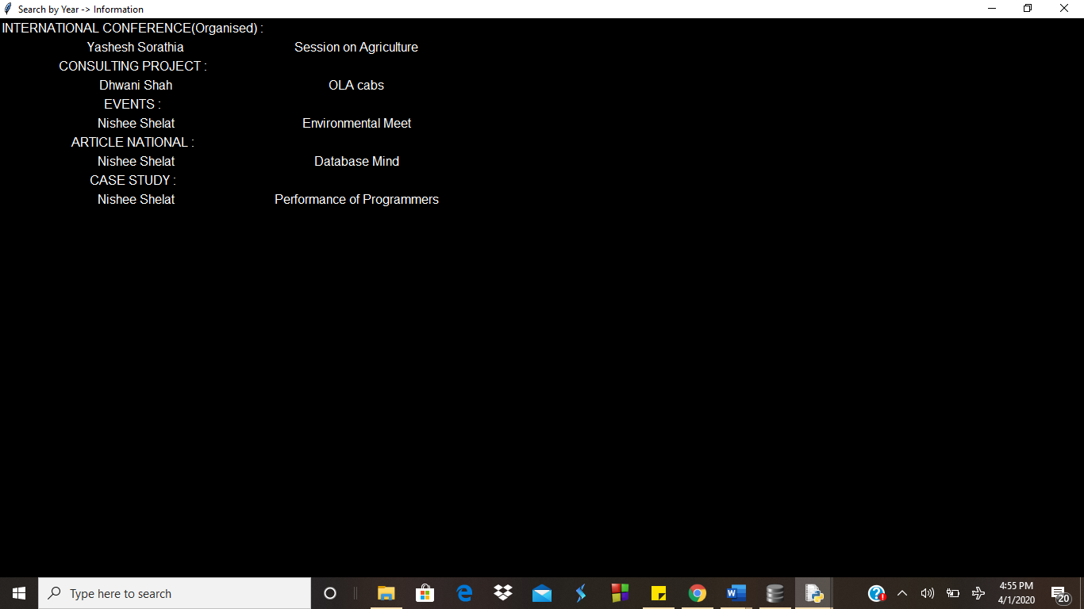

**Search by Professional Parameter:** There would be radio buttons of different parameters and after selection of one all the details about the said parameter accomplished by various faculties will be displayed.

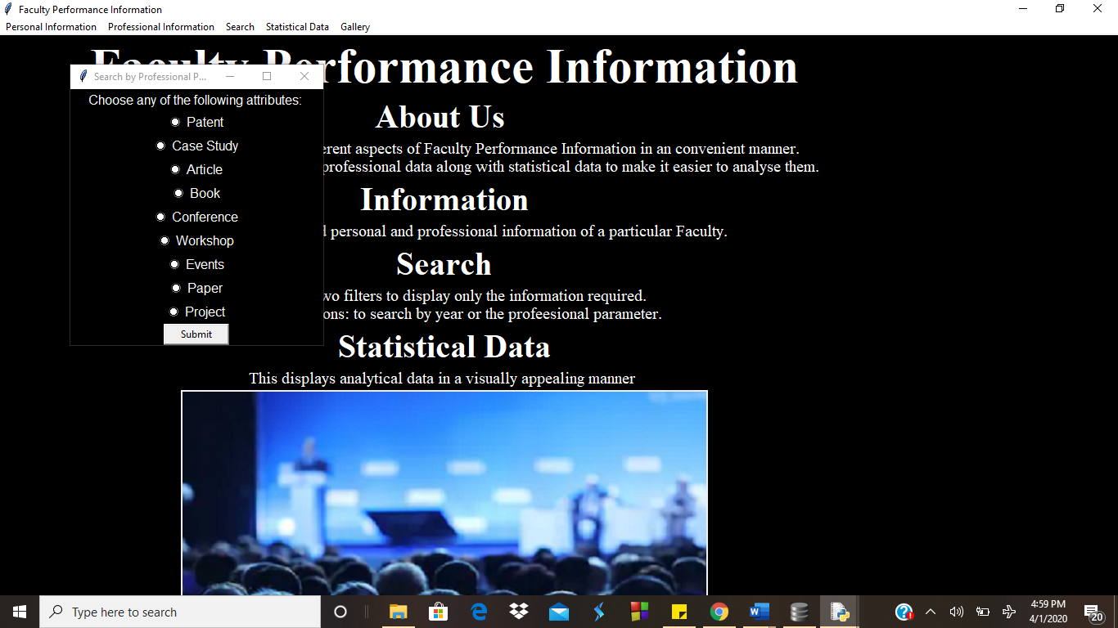

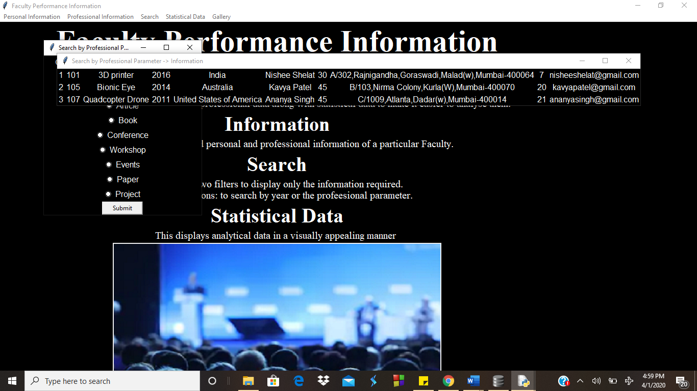

**Statistical Data:** All the professional information are displayed in a pie chart format after analyzing the data.

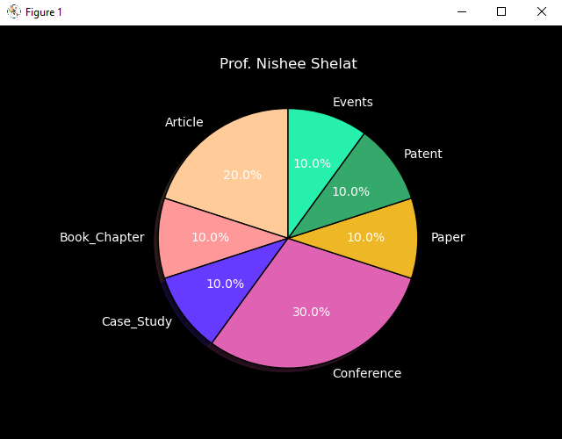

**Gallery:** A gallery to show the validation of the information mentioned.

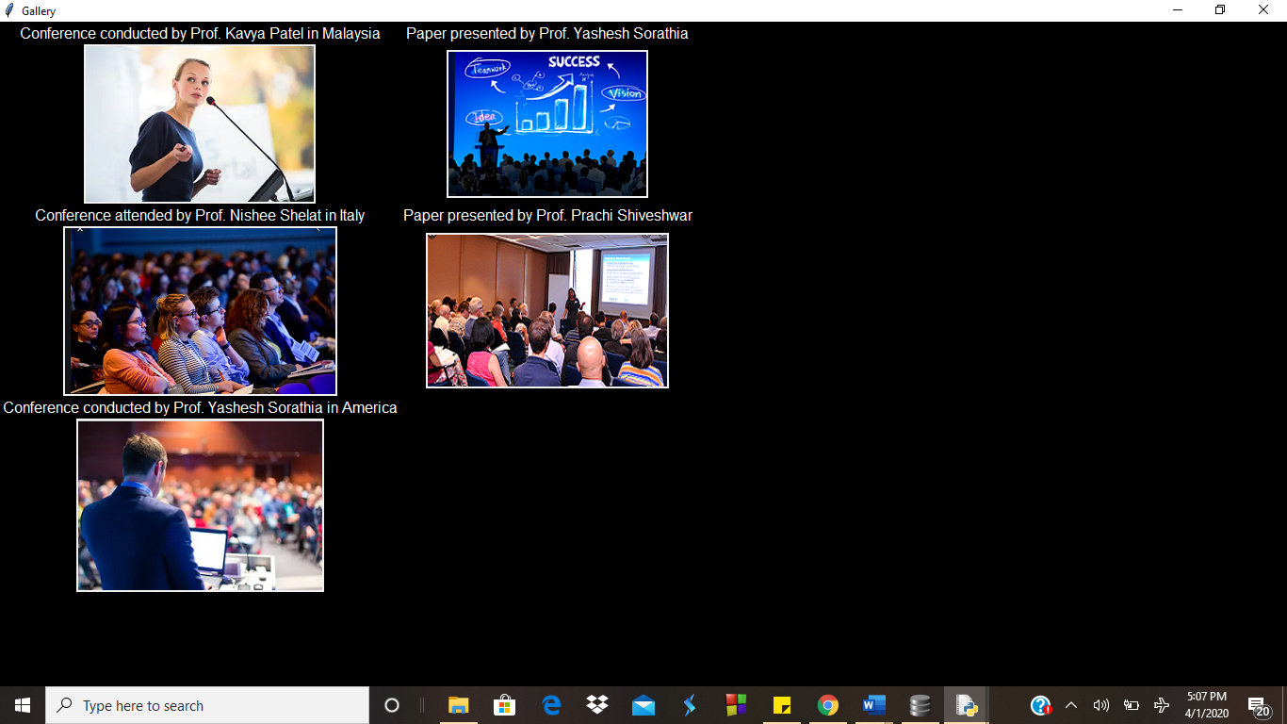

**CONCLUSION AND FUTURE SCOPE**

Thus, we have successfully developed a management system that very well categorises and securely stores, the data of faculty members belonging to a particular university and have linked it to Python for firing queries efficiently. Python plays a vital role to store and display information as and when needed.

We have also successfully implemented all the functionalities of DB Browser and made utmost use of Python GUI Tkinter to the best of our knowledge to develop a database system for the personal progress of the faculty members in a university.

This system allows you to view data on the basis of a certain year when the said parameter was accomplished and also allows us to see various faculty’s contribution in one specific parameter. It also all lets us view the number of advancements they have made in a particular parameter as their professional information.

It also displays faculty’s personal information along with their image. There is a separate window which displays statistical data of a specific faculty in terms of a pie chart in various parameters versed by them. System also has a gallery to show the validation of the information mentioned.

Its further scope could be to make a login page which creates a layer of security for authoritative people to modify the data in the database system. This login would be used only by Administrators and Faculty if required to provide the needed protection of data.